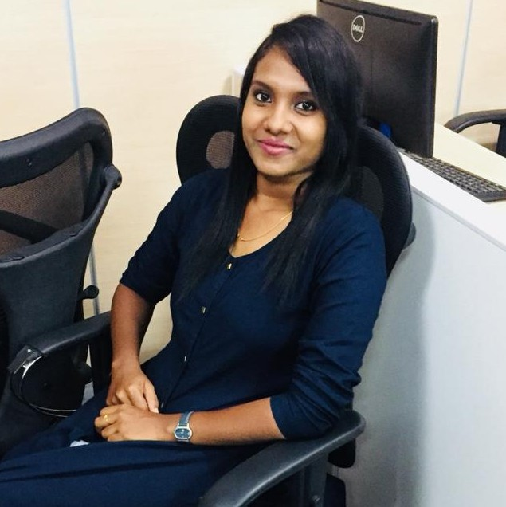
E
W
Validation Engineer
Sindhu Sundaramoorthy
Programmer Analyst in Cognizant Technology Solutions
Chennai / June 2018- Nov 2021
- Requirement gathering and analysis.
- Develop Validation Test Plans in accordance with regulatory requirements and SOP’s.
- Develop and execute validation protocols (OQ, PQ).
- Review of OQ’s for both pre-approval and post-approvals.
- Conducted manual testing across various platforms - web, mobile and desktop applications to identify defects and ensure adherence to requirements.
- Identified, documented and tracked software defects using bug tracking systems and worked closely with development teams to prioritize and resolve issues.
- Performed regression testing to validate software fixes to ensure the stability of new releases.
- Preparation and review of Traceability matrix
Validation Engineer in Vaisesika Consulting Pvt Ltd
Bangalore / Nov 2021 - Present
- Strong knowledge across various Team Management Activities - Test Case Preparation and Execution, Test Plan, Defect tracking, RTM preparation and maintenance.
- Supported Validation Lead activities such as Validation Plan, OPQ execution and review and Validation Summary Report.
- Assist the team members on ALM related activities.
- Supported VAF (Vaisesika AI Framework) for OPQ execution and review.
- Expertise in preparing project status reports (Weekly and Daily)
B.COM
Commerce
SRM University
2014 – 2017
EDUCATION
SKILLS
Overall 5+ years of experience in IT - life science domain. Have Strong knowledge in STLC (Software Testing Life Cycle) with expertise in Requirement analysis, Test planning, Test execution and Defect management. Proficient in preparation of Validation Plan, Validation Protocols (Operational Qualification), Defects, RTM and Validation Summary Report. Good exposure to the test management tool ALM and JIRA.
PROFESSIONAL SUMMARY
Soft Skills
- Analytical Thinking
- Time Management
- Creativity
- Problem-Solving
- Adaptability
Hard Skills
- Validation Testing
- SQL
- ALM
- JIRA
+91 7358374455
sindhu.sundaramoorthy@vaisesika.in
Chennai, Tamil Nadu, 603103
sindhu-sundaramoorthy

